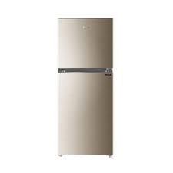

HAIER 398EBD

* Full Electric Solution
* Free Standing
* Gold Color
* Hidden Door Handles
* **Rs. 49,400**